CSY3013

**Software Engineering 3**

**Assignment**

**Assignment Report**

**Submitted By**

**Student Name: Pukar karki**

**Uni. ID: 23834850**

Table of Contents

**1.** **Introduction** 3

**1.1.** **Project Background** 3

**1.2.** **Project Aims and Objectives** 4

**2.** **Requirements Engineering** 5

**2.1.** **Elicitation Activities** 5

2.1.1. Individual Workshop 1 plan (Problem Domain Understanding) 5

2.1.2. Group Workshop 1 Plan (Problem Domain Understanding) 7

2.1.3. Workshop 1 findings (Problem Domain Understanding) 10

2.1.4. Individual Workshop 2 Plan (Problem Resolution and Specification Formulation) 11

2.1.5. Group Workshop 2 Plan (Problem Resolution and Specification Formulation) 13

2.1.6. Workshop 2 Findings (Problem Resolution and Specification Formulation) 17

2.1.7. Workshop Observation Critical Review 18

2.1.8. Other Problem Domain Research 18

**2.2.** **Requirements Specification** 23

2.2.4. Problem Domain Description 23

2.2.5. Functional Requirements 25

2.2.6. Non-functional Requirements 26

2.2.7. Proposed Prototype Development Blocks/Priority of Development 27

3. System Analysis & Design (Software Development Block/Sprint 1) 29

4. System Build and Technical Notes (Software Development Block/Sprint 1) 38

5. System Testing & Evaluation Strategy (Software Development Block/Sprint 1) 39

6. Conclusion 40

References 41

# **Introduction**

## **Project Background**

Fotheby’s International Auction House currently relies heavily on manual processes to manage its inventory and client interactions. This includes the physical listing of auction items, manual tracking of bids, and offline communication with clients. Such practices are time-consuming, prone to human error, and inefficient in meeting the demands of a growing and diverse client base. To address these limitations, the organization seeks a digital solution that will streamline auction processes, improve client experience, and enhance operational efficiency. The project proposes the development of an online auction system to automate item management, bidding, and customer engagement in a secure and user-friendly environment. (Anon., n.d.)  
The new system aims to centralize all auction-related activities into a single digital platform, offering real-time updates, intuitive interfaces, and access from any location. This transformation will not only modernize the business model but also position Fotheby’s as a competitive player in the global digital auction market.

## **Project Aims and Objectives**

**Aim**:

To design and implement a secure, user-friendly online auction system that digitizes Fotheby’s inventory and streamlines the bidding process. The system will enhance operational efficiency, ensure transparent transactions, and offer global accessibility—providing faster access to auction details and improving client service and engagement across various user roles, including bidders, sellers, and administrators. (Anon., n.d.)

**Objectives:**

1. **User Registration and Authentication**  
   Develop a secure registration and login system to manage user access and protect user data. The system will enforce strong password policies, prevent duplicate accounts, and provide role-based access control to distinguish between users and administrators.
2. **Seller Item Listing Functionality**  
   Allow approved sellers to create detailed auction listings by submitting item descriptions, images, reserve prices, and starting bid amounts. Listings will be editable before the auction starts and subject to approval by an admin to ensure compliance with quality standards.
3. **Bidding and Bid History Features**  
   Enable registered bidders to place real-time bids during active auctions. The system will maintain and display a transparent bid history for each item, showing the current highest bid, time stamps, and bidder pseudonyms to ensure fairness and traceability.
4. **Administrative Monitoring and Control Panel**  
   Provide administrators with a control panel to manage users, approve or reject listings, moderate suspicious bidding activity, and generate reports on sales, user engagement, and system activity. This module will support system maintenance and operational oversight.

# **Requirements Engineering**

Requirements engineering is a critical phase in the system development lifecycle that focuses on identifying, analyzing, documenting, and validating the functional and non-functional requirements of a system. It ensures that the final product meets user expectations and aligns with business goals. This phase lays the foundation for system design and implementation by establishing a clear understanding of what the system must achieve.

## **Elicitation Activities**

Requirements elicitation is the process of collecting relevant information from stakeholders, end-users, and other relevant parties to understand their needs and expectations from the system. Effective elicitation is essential to ensure that the software addresses actual problems and provides value. Techniques used in this phase can include interviews, observations, questionnaires, workshops, and document analysis.

### Individual Workshop 1 plan (Problem Domain Understanding)

This workshop was designed to gain insight into the existing manual auction process at Fotheby’s International Auction House. The goal was to identify inefficiencies, bottlenecks, and stakeholder frustrations, which would help in framing the functional scope of the digital auction system.

#### Rationale

The rationale behind conducting Individual Workshop 1 was to engage directly with staff members involved in the daily operations of the auction house. By interviewing stakeholders individually, we aimed to capture diverse perspectives and gain an in-depth understanding of the problems and limitations they face in the current manual workflow. This early engagement helped uncover critical insights that guided the formulation of system requirements.

#### Agenda/Tool Selection

To keep the session focused and productive, a structured agenda was followed:

**Introduction (5 minutes):** Briefed participants about the purpose of the workshop and how their input would shape the new system.

**Interview with Staff (25 minutes):** Conducted one-on-one interviews to understand their roles, challenges with current processes, and desired features in the new system.

**Notes Documentation (10 minutes):** Summarized findings and observations from each interview to aid further analysis.

**Tools Used:** A simple and effective combination of traditional tools such as **ballpen and paper** for taking immediate notes and **Notepad** software for digital transcription and organization of information. These tools ensured that no detail was overlooked and allowed for easy sharing among the project team.

#### Participant Engagement Commitment

To ensure productive and respectful collaboration throughout the workshop:

* **Respect the Surroundings:** Maintained a professional and quiet environment to facilitate clear communication and attentiveness.
* **Equality of Participation:** Encouraged each staff member to freely express their thoughts and experiences without any hierarchy or bias.
* **Mutual Understanding:** Emphasized active listening and empathy to build trust between the interviewers and stakeholders, ensuring that insights gathered were honest and constructive.

### Group Workshop 1 Plan (Problem Domain Understanding)

The Group Workshop 1 was organized to facilitate collaborative discussion among multiple stakeholders involved in Fotheby’s auction process. Unlike individual interviews, this group session aimed to encourage interaction, spark idea-sharing, and collectively explore the broader problem domain.

|  |  |  |
| --- | --- | --- |
| **Interviewer** | **Interviewer** | **Questions** |
| Mausam Sunuwar | Mr. Max Fotheby (Owner & Manager) | **What problems do you currently face with the manual auction catalog and inventory system?** |
| **What are your top priorities for the new system?** |
| Amisha Tamang | **Are there any legal, compliance, or record-keeping needs the system should handle?** |
| Mr. Mark Jones (Existing Regular Buyer/Seller) | **What features would make listing and tracking your items easier online?** |
| Pragyan Tamang | **Would you like to save favorite items or receive reminders before bidding closes?** |
| **Would you use filters like artist, price, or item type to help you browse auctions?** |
| Sudip Sapkota | Mr. Paul Smith (Client who moved to competitors) | **What features would bring you back to Fotheby’s?** |
| Pukar Karki | **What kind of help or customer support do you expect when using an online auction platform?** |
| Aadarsha Shahi | **Do you use mobile devices for bidding or tracking auctions? If yes, what features should a mobile version have?** |

#### Rationale

The primary objective of this group workshop was to collectively analyze and consolidate the findings from individual stakeholder interviews. By validating and cross-referencing individual insights in a shared environment, the workshop aimed to reduce misunderstandings and confirm a mutual understanding of key system requirements. It also offered an opportunity for stakeholders to provide immediate feedback, clarify discrepancies, and reach a consensus on high-priority features. This step was crucial in ensuring the final requirement set is well-aligned with user needs and organizational goals.

#### Agenda/Tool Selection

The session followed a structured agenda to keep discussions focused and productive:

* Recap of Individual Observations (10 mins):

The session began with a summary of the key issues, challenges, and expectations identified during the one-on-one interviews. This helped refresh participants’ memory and set the context for group discussion.

* Requirements Brainstorming (20 mins):

Participants were encouraged to suggest system functionalities, raise concerns, and propose solutions based on their experience. The interactive brainstorming session allowed the group to collaboratively outline initial functional and non-functional requirements.

* Tools Used:
* Notepad: To individually note observations and personal suggestions before open discussion.
* Whiteboard: To map out ideas, show relationships between requirements, and visually prioritize features in real-time.

These simple yet effective tools facilitated open collaboration while allowing the team to track ideas and decisions efficiently.

#### Participant Engagement Commitment

To ensure an inclusive and respectful environment that promotes meaningful participation, the following engagement commitments were upheld:

* **Turn-Taking:**  
  Each participant was given equal opportunity to speak without interruption. A turn-taking approach ensured that all voices were heard, particularly those of quieter participants who might otherwise be overshadowed in group settings.
* **Documenting Insights:**  
  A dedicated note-taker was assigned to record all key points discussed. This ensured that valuable insights were preserved and could be referenced in later stages of requirements development and system design.
* **Stakeholder Feedback:**  
  Time was allocated at the end of the workshop to invite feedback on the session itself and confirm that all major concerns were addressed. This practice reinforced trust and strengthened stakeholder engagement in the development process.

### Workshop 1 findings (Problem Domain Understanding)

1. As part of the initial requirements-gathering phase, a group workshop was conducted to understand the key challenges, expectations, and preferences of stakeholders regarding the current manual auction catalog and inventory system at Fotheby’s. Below are the summarized findings: (Anon., n.d.)

|  |  |
| --- | --- |
| **Question** | **Response** |
| What problems do you currently face with the manual auction catalog and inventory system? | All tasks are performed manually, and there is no proper inventory tracking, making it inefficient. |
| What are your top priorities for the new system? | The main priority is to eliminate manual processes and introduce automation for better efficiency. |
| Are there any legal, compliance, or record-keeping needs the system should handle? | Yes, the system must comply with UK government regulations regarding auctions and data handling. |
| What features would make listing and tracking your items easier online? | A robust search feature would greatly improve listing and tracking of items. |
| Would you like to save favorite items or receive reminders before bidding closes? | Not considered mandatory, but it could be a useful addition in the future. |
| Would you use filters like artist, price, or item type to help you browse auctions? | Filters are considered essential to help users narrow down and browse items effectively. |
| What features would bring you back to Fotheby’s? | Features like an online catalogue, bid tracking, and timely updates would enhance user engagement. |
| What kind of help or customer support do you expect when using an online auction platform? | A simple and accessible customer support feature, including a Contact and Help page, is expected. |
| Do you use mobile devices for bidding or tracking auctions? If yes, what features should it have? | No specific requirements were given for mobile use at this stage. |

These insights serve as the foundation for designing a user-centric, legally compliant, and efficient online auction system tailored to the needs of Fotheby’s stakeholders. (Anon., 2025)

### Individual Workshop 2 Plan (Problem Resolution and Specification Formulation)

After understanding the current challenges and gathering initial requirements in Workshop 1, Individual Workshop 2 was conducted with key stakeholders to focus on clarifying, refining, and formalizing the system requirements. This workshop aimed to resolve any remaining ambiguities, prioritize system features, and begin formulating specific functional and non-functional requirements to guide the system's design.

#### Rationale

The main purpose of this individual session was to translate the findings from earlier workshops into concrete and actionable system specifications. By meeting stakeholders individually, the development team could focus on specific concerns, gather more focused feedback, and refine previously identified features. This approach allowed for a detailed discussion of solution options to address the problems observed in the manual auction process, such as slow item listings, limited bid tracking, and inefficient client communication.

The session helped bridge the gap between problem identification and solution planning by:

* Finalizing functional requirements such as user registration, item listing, and bidding mechanisms.
* Discussing technical constraints and user preferences.
* Identifying features that are critical for system operation (must-have) versus those that are optional or value-adding (nice-to-have).

#### Agenda/Tool Selection

To maintain structure and ensure productive outcomes, the workshop followed this agenda:

* **Review Workshop 1 Data:**  
  Begin by revisiting the data and feedback gathered from previous individual and group workshops. This sets the context and reminds participants of the previously raised issues and ideas.
* **Differentiate Must-Have and Nice-to-Have Features:**  
  Stakeholders are guided through a prioritization exercise to identify which features are essential for the Minimum Viable Product (MVP) and which features can be considered for future updates. This helps in resource planning and scope management during the development process.
* **Draft Functional Requirements:**  
  Using the refined input, the team and stakeholders work together to draft functional requirements. These include specific features such as:
* User authentication (registration, login)
* Seller item listings with descriptions and starting prices
* Bid placement and bid history
* Admin control panel
* **Tools Used:**
  + **Notepad:** For jotting down participant responses and observations in a flexible format.
  + **Spreadsheet:** Used for listing features and categorizing them into must-have vs. nice-to-have. This helped visualize priorities and establish clear requirement documentation.

#### Participant Engagement Commitment

To maintain a professional and constructive environment, the following engagement commitments were upheld:

* **Clarity and Precision in Requirement Formulation:**  
  Participants were encouraged to be specific and unambiguous in their suggestions and expectations. Clear descriptions reduce the risk of misinterpretation and ensure the development team builds exactly what is needed.
* **Equality of Participation:**  
  Regardless of role or technical expertise, each participant’s opinion was treated with equal importance. This inclusiveness fostered a collaborative atmosphere and ensured that insights from both technical and non-technical users were considered in the final requirement set.

### Group Workshop 2 Plan (Problem Resolution and Specification Formulation)

|  |  |  |
| --- | --- | --- |
| **Interviewer** | **Interviewer** | **Questions** |
| Mausam Sunuwar | Mr. Max Fotheby (Owner & Manager) | What key administrative tasks do you want to automate in the new system? |
| Who will use the system, and what permissions or access should each role have? |
| Amisha Tamang | Would you like to show upcoming auctions or featured items on the homepage? |
| Should your company logo appear on every page and in what position; top-left or center? |
| Pragyan Tamang | Would you prefer auction management in a grid or a tabular list? |
| Mr. Mark Jones (Existing Regular Buyer/Seller) | Should sellers get alerts when someone bids on their item? |
| Sudip Sapkota | How should commissions and fees be calculated and displayed in the system? |
| Would you like items to be shown in a list or a grid view? |
| Pukar Karki | How many items should be shown per page in a listing? |
| Mr. Paul Smith (Client who moved to competitors) | Would you prefer users to register before bidding, or should guest bidding be allowed with limited features? |
| Aadarsha Shahi | Would a live countdown timer during bidding be useful? |
| Would you prefer a fixed navigation bar at the top or one that scrolls with the page? |
| Should the layout be more image-based or more focused on detailed information? |

#### Rationale

The primary goal of this session was to **collectively review, validate, and finalize the proposed system requirements**. By involving all stakeholders in one group discussion, the development team ensured that:

* There is a **shared understanding** of the project's scope.
* Any remaining disagreements or misunderstandings are addressed.
* The team has a **clear and unified direction** moving into system design and implementation.

This collaborative validation is crucial to reduce scope creep, avoid later-stage rework, and ensure stakeholder satisfaction with the final product. It also helped in setting the stage for realistic planning and resource allocation.

#### Agenda/Tool Selection

To achieve the goals of this session, a structured agenda and practical tools were selected:

* **Recap of Individual Findings:**  
  The session began with a summary of insights and requirements collected during individual workshops. This ensured that everyone was on the same page and reminded participants of the diverse needs and issues raised earlier.
* **Confirm Priorities with Stakeholders:**  
  With all stakeholders present, the group reviewed the prioritization of features (must-have vs. nice-to-have) and discussed any conflicting priorities. This collaborative process enabled participants to **negotiate trade-offs** and **reach agreement** on what the initial system release should include.
* **Tools: Notepad++:**  
  Notepad++ was used during the session to **record live edits to the requirements list**, make annotations, and save feedback in a well-structured digital format. It provided a fast, clear, and organized way to update and share requirement documents in real time.

#### Participant Engagement Commitment

To ensure a productive and respectful environment, participants were expected to uphold the following commitments:

* **Respect Differing Perspectives:**  
  Stakeholders came from different departments (e.g., admin, sellers, IT, clients), each with unique priorities and insights. Respecting each other's views fostered a **collaborative spirit** and led to more balanced and inclusive requirements.
* **Ensure Transparency:**  
  All discussions, decisions, and justifications were documented and openly shared among participants. Transparency throughout the process helped build **trust in the project**, kept everyone aligned, and ensured that no voice or concern was overlooked.

### Workshop 2 Findings (Problem Resolution and Specification Formulation)

In the second workshop session, the team focused on administrative functionality, user roles, layout preferences, and auction-specific features. The following table summarizes the responses and decisions gathered during this session: (Anon., 2025)

|  |  |
| --- | --- |
| **Question** | **Response** |
| What key administrative tasks do you want to automate in the new system? | User and inventory management should be automated to improve efficiency. |
| Who will use the system, and what permissions or access should each role have? | There will be two types of users: general users and administrators, each with specific permissions. |
| Would you like to show upcoming auctions or featured items on the homepage? | Yes, displaying upcoming auctions or featured items on the homepage would be beneficial. |
| Should your company logo appear on every page and in what position; top-left or center? | Yes, the logo should appear on every page in the top-left corner. |
| Would you prefer auction management in a grid or a tabular list? | For admins, a tabular list view is preferred for better data management. |
| Should sellers get alerts when someone bids on their item? | Sellers should be notified if their item is sold. |
| How should commissions and fees be calculated and displayed in the system? | Commissions should be automatically deducted and shown clearly in the seller’s dashboard. |
| Would you like items to be shown in a list or a grid view? | Either view is acceptable; flexibility between both is preferred. |
| How many items should be shown per page in a listing? | Between 5 to 7 items per page is ideal for clear browsing. |
| Would you prefer users to register before bidding, or should guest bidding be allowed? | Guest bidding should not be allowed; users must register before placing bids. |
| Would a live countdown timer during bidding be useful? | A countdown timer is not mandatory but may be considered as an enhancement. |
| Would you prefer a fixed navigation bar at the top or one that scrolls with the page? | A fixed navigation bar is not necessary if it interferes with browsing; consider keeping it simple. |
| Should the layout be more image-based or more focused on detailed information? | Both image-based and detail-focused elements should be incorporated for a balanced layout. |

These findings provide further clarity on the expected administrative features, user experience, and functional layout of the system, helping to shape a comprehensive and user-friendly auction platform. (Anon., n.d.)

### Workshop Observation Critical Review

The workshop exhibited several strengths, such as having a well-structured agenda, maintaining clear communication, and utilizing user stories effectively to illustrate requirements. However, there were notable weaknesses, including inconsistent levels of participation and some uncertainty around feature prioritization. Suggested improvements involved incorporating visual diagrams to clarify ideas and rotating facilitators in future workshops to maintain participant engagement and enthusiasm. (Sotheby's, n.d.)

### Other Problem Domain Research

#### Comparable Software System Review



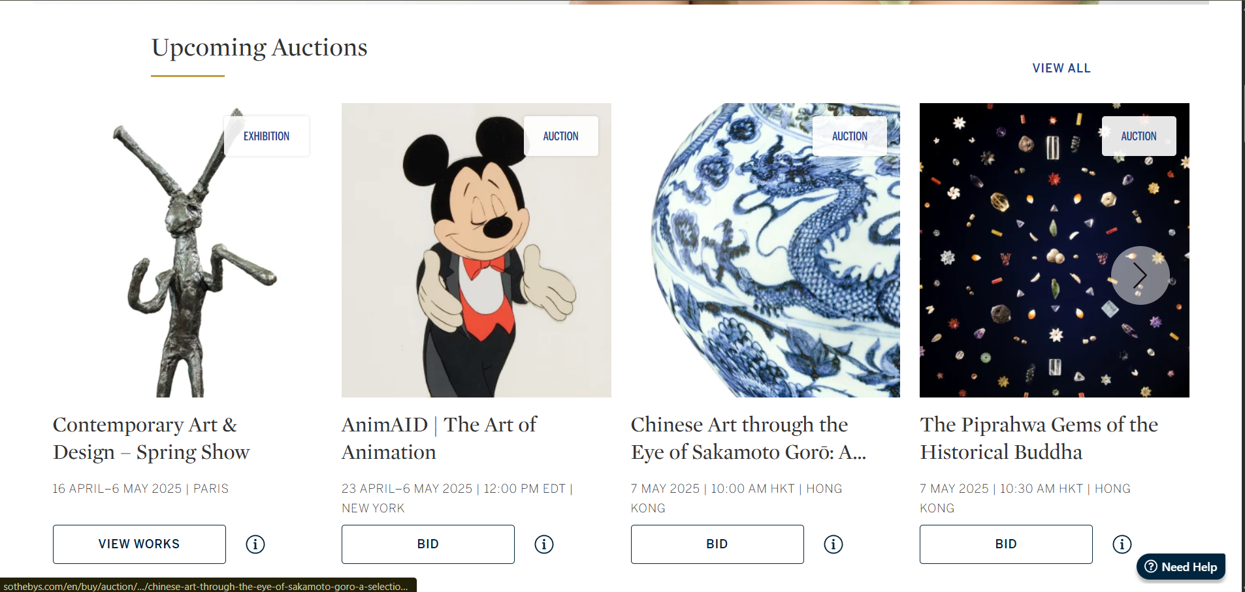

*fig: Sotheby’s Auction house*

**Comparable System: Sotheby’s Online Auction Platform**

**Sotheby’s**, a globally recognized auction house, has developed a well-established digital platform that allows users to explore auctions, bid online, and engage in private sales. The system offers: (Sotheby's, n.d.)

* **Aesthetically pleasing design** with high-resolution item images.
* **Clear categorization** of auction types (e.g., Buy Now, Private Sales).
* **Auction previews** that display dates, times, and item locations.
* **Efficient bidding process** and a responsive UI.
* **Customer support** tools like live chat ("Need Help") and special access options for premium clients.

However, despite its reputation and professional appearance, Sotheby’s system has certain **limitations**, which the proposed **Fotheby’s Online Auction System** aims to address:

**Improvements Offered by the Fotheby’s System**

1. **Simplified User Journey**  
   While Sotheby’s targets a high-end audience, its platform can appear overwhelming to first-time users. Fotheby’s will prioritize **user-friendliness**, ensuring even novice users can navigate auctions, place bids, and register easily.
2. **Faster Registration and Bidding Flow**  
   Sotheby’s requires several steps before a user can participate in an auction. Fotheby’s system will enable **quick registration/login and seamless bidding** with minimal friction, especially for mobile users.
3. **More Inclusive and Accessible Design**  
   The Fotheby’s platform will include **accessibility features** (text size options, screen reader compatibility, multi-language support), making it more inclusive compared to Sotheby’s English-heavy, visually complex interface.
4. **Dedicated Seller Dashboard**  
   Fotheby’s system will empower sellers with a **user-friendly dashboard** to track views, bids, and auction status, unlike Sotheby’s seller experience which is mostly backend-controlled and less transparent.

In summary, while Sotheby’s sets a high standard for digital auction systems, Fotheby’s aims to **democratize and modernize** the experience—making online auctions more accessible, responsive, and intuitive for a wider range of users.

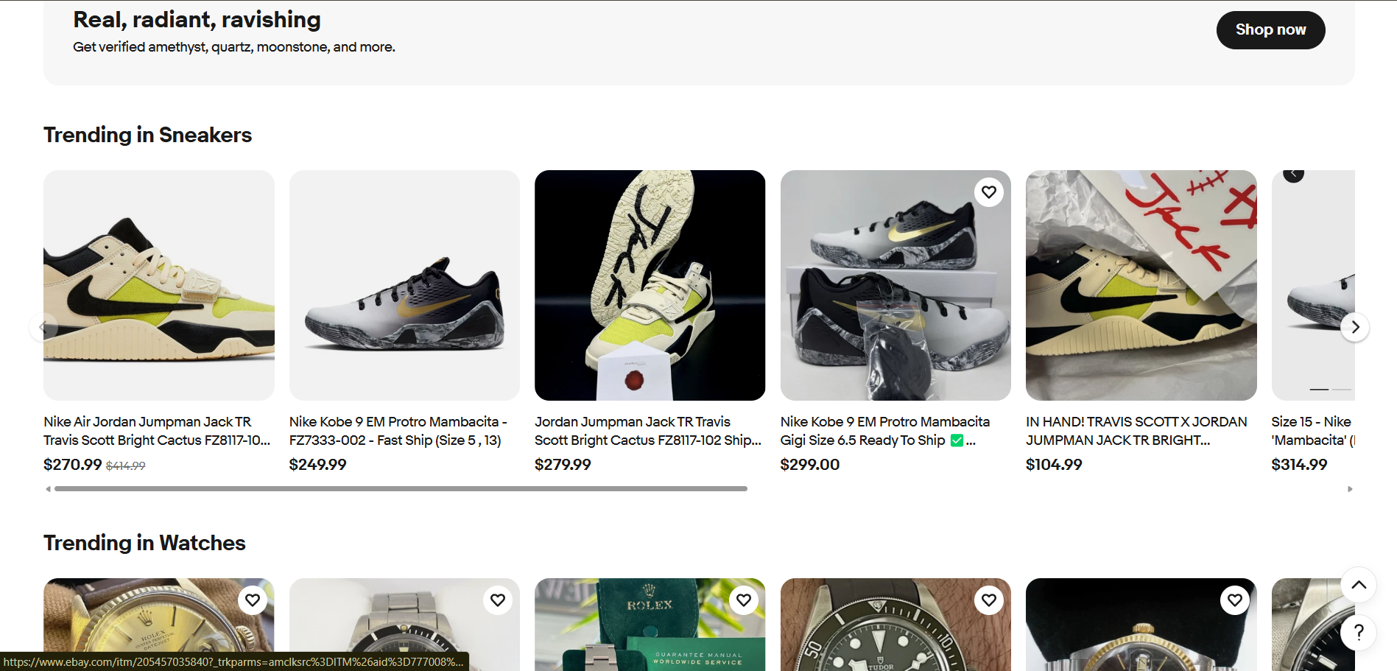

*fig: eBay website*

**Comparable System: eBay**

**eBay** is a globally popular e-commerce and auction platform that supports both fixed-price sales and bidding. Key features include:

* **Trending products and categories** (e.g., Sneakers, Watches).
* **Real-time pricing and bidding interface**.
* **Wide range of sellers**, from individuals to stores.
* **Built-in buyer/seller rating system**.
* **Mobile-friendly experience with easy navigation**.

While eBay offers a highly functional marketplace, the proposed **Fotheby’s System** enhances the experience in several specific ways:

**How Fotheby’s Improves Upon eBay**

1. **Focused Curation for Quality Listings**  
   Unlike eBay’s massive, sometimes overwhelming inventory, Fotheby’s will offer **curated and verified listings**, ensuring authenticity and quality—especially useful for collectibles, fine art, or niche items.
2. **Auction-Centric Model**  
   eBay blends fixed-price and auction sales. Fotheby’s will provide a **fully auction-driven experience**, making it more exciting, time-bound, and competitive for buyers and sellers.
3. **Better Visual Presentation**  
   eBay listings can look cluttered and inconsistent. Fotheby’s will enforce **standardized photo layouts, product descriptions, and image quality**, offering a more professional appearance akin to Sotheby’s.
4. **Community and Engagement Tools**  
   Fotheby’s will feature **watchlists and live countdowns** for auctions, building a stronger community experience that’s often missing from eBay's transactional interface.

By positioning Fotheby’s between **Sotheby’s luxury niche** and **eBay’s massive marketplace**, you’re offering a **refined yet accessible auction platform**—ideal for users who want quality, trust, and excitement in one system.

## **Requirements Specification**

### Problem Domain Description

The current business operates within the online marketplace for high-value collectibles, such as artwork, jewelry, antiques, and luxury items. As a digital platform, it must not only provide a seamless and engaging user experience but also adhere to strict legal, operational, and technical requirements to maintain trust and functionality. The industry relies heavily on the accuracy of listings, secure financial transactions, and efficient user interactions—especially in competitive auction environments. (Sotheby's, n.d.)

* + - 1. Existing Business Operation

The current system must function within a strict legal and regulatory framework, particularly due to its handling of personal data, e-commerce transactions, and content rights. The core compliance requirements include:

* **General Data Protection Regulation (GDPR)**: This law ensures that any data collected from clients—such as names, email addresses, and transaction histories—is securely stored, processed fairly, and only used with explicit consent. It also gives users the right to access, modify, or request deletion of their data.
* **UK Distance Selling Regulations**: These regulations require businesses to be fully transparent in their online dealings. They must provide clear details about the goods or services, pricing, delivery timelines, refund policies, and cancellation rights before any purchase is finalized.
* **Copyright Law Compliance**: Since the platform deals with art, antiques, and collectible items, it must ensure that all textual descriptions and images used to promote or sell these items are either owned by the business or used with proper permissions. Unauthorized use of copyrighted materials can lead to legal disputes and reputational damage.

Overall, while the current business operates with an awareness of legal obligations, the lack of robust digital infrastructure exposes it to operational inefficiencies and risks.

#### Summary of Existing Business Limitations

Fotheby’s current auction operations rely heavily on manual, clerical systems for maintaining inventory and managing auction-related records. While functional, this traditional approach presents several challenges in today’s competitive and fast-paced art market:

* **Time-consuming searches**: The clerical inventory system makes it difficult for staff and clients to efficiently search for specific items or track past auction records, leading to delays and reduced productivity. (Anon., 2025)
* **Limited catalogue distribution**: The printed auction catalogue is the primary promotional tool, but with only around 5,000 copies produced for each event, client reach is restricted. This significantly limits exposure of the items, especially to international audiences who may not have access to the physical catalogue, thus reducing the potential buyer base and limiting international participation.
* **No real-time bid tracking**: Without a digital platform, clients cannot track bidding activity in real time, which is a standard feature in modern auction platforms. This reduces transparency and limits engagement during live auctions. (Anon., n.d.)
* **Prone to data loss**: Paper-based records are more vulnerable to loss, misplacement, or damage, posing a risk to data integrity and business continuity.
* **Poor customer satisfaction during follow-ups**: Due to lack of automation, post-auction services like follow-ups, payment processing, and item tracking are often delayed, affecting client satisfaction. (Anon., n.d.)
* **Missed digital opportunities**: The absence of a web-based platform means Fotheby’s is missing out on potential global buyers, improved marketing capabilities, and higher bidding competition — all of which could lead to increased final sale prices.

### Functional Requirements

To address the limitations of Fotheby’s existing clerical system and meet the needs of a modern, efficient auction house, the proposed digital system will include the following core functionalities: (Anon., 2025) (Anon., n.d.) (Sotheby's, n.d.)

* **Adding Auction and Lot Details to the Database**  
  Administrators and authorized staff will be able to input new auction events and corresponding lot items into the database through a user-friendly interface. Each entry can include essential information such as auction title, date, location, item name, artist, description, estimated price, and image uploads. This functionality streamlines the preparation and organization of auction events.
* **Modifying Existing Auctions and Lot Details**  
  The system will allow authorized users to edit existing entries within the auction database. This includes correcting data, updating item information (e.g., revised price estimates), rescheduling auctions, or adding more descriptive details and images. Ensuring the flexibility to edit records minimizes errors and keeps auction information accurate and up-to-date.
* **Deleting or Archiving Auction and Lot Details**  
  Auctions or lot items that are no longer active can either be permanently deleted or archived for record-keeping purposes. Archiving allows the business to maintain historical data without cluttering the active listings, while deletion can be used for test entries or invalid records. Access to this function will be restricted to admin-level users for security.
* **Displaying Auction and Individual Lot Information**  
  The website will feature well-organized listings that display auction events and the corresponding items (lots) in a visually appealing and user-friendly manner. Clients will be able to browse through upcoming and past auctions, with each lot showing key details such as title, artist, image, description, and estimated value. This supports client interest and transparency.
* **Search and Filtering Mechanism**  
  To improve user experience, the system will include a search function with simple filtering options (e.g., by artist, category, price range, date). This will allow clients and staff to quickly locate auctions or specific items of interest from the database, replacing time-consuming manual searches and significantly enhancing usability.

### Non-functional Requirements

While functional requirements describe what a system should do (e.g., “users can place bids on items”), non-functional requirements describe how well the system performs those functions. They define the quality attributes of the system, such as its reliability, security, usability, and performance.

Think of NFRs as the “-ilities” of your system — things like availability, scalability, and maintainability. (Anon., n.d.) (Sotheby's, n.d.)

|  |  |
| --- | --- |
| **NFR Type** | **Explanation & Relevance to Fotheby’s** |
| **Security** | The system should encrypt user data (e.g., passwords, bids), protect against fraud, and ensure secure payments. Essential to build **trust** in the auction process. |
| **Performance** | The system must respond quickly, even when many users are bidding at once. Long delays can frustrate users and cause them to lose auctions. |
| **Scalability** | The system should handle growth — more users, more auctions, and higher traffic — without needing a complete redesign. |
| **Usability** | Interface should be intuitive for users of all levels (sellers, buyers, admins). Simplicity helps reduce mistakes and support costs. |
| **Reliability** | The system must function consistently without crashes or unexpected errors, especially during live bidding sessions. |
| **Maintainability** | The system should be easy to update and fix, e.g., for bug fixes or adding features in the future. |
| **Legal Compliance** | The platform must follow laws like GDPR (data protection) and copyright regulations. This avoids legal risks. |

### Proposed Prototype Development Blocks/Priority of Development

The prototype for Fotheby’s online auction system will be developed incrementally in structured blocks to ensure core functionalities are prioritized and built upon iteratively. Each development block represents a group of related features, arranged by urgency, dependency, and impact on the system’s operation. The timeline below estimates the implementation schedule over five weeks.

|  |  |  |  |
| --- | --- | --- | --- |
| **Block** | **Features** | **Timeline** | **Priority** |
| 1 | Add/Edit/Delete/View Lot | Week 1 | High |
| 2 | Basic search/filter | Week 2 | High |
| 3 | Client registration/profile | Week 3 | High |
| 4 | Commission bidding | Week 4 | Low |
| 5 | Sales and commission tracking | Week 5 | Medium |

**Block 1: Add/Edit/Delete/View Lot – Week 1 (High Priority)**

This block establishes the fundamental ability to manage auction lots in the database. Admins will be able to create, update, view, and delete auction items, laying the groundwork for the rest of the system. It is crucial to complete this first, as other features rely on lot data being available and accurate.

**Block 2: Basic Search/Filter – Week 2 (High Priority)**

Following the creation of lot entries, users must be able to search and filter these items based on various criteria (e.g., artist, category, price). This improves navigation and usability, ensuring users can quickly find items of interest in a growing inventory.

**Block 3: Client Registration/Profile – Week 3 (High Priority)**

A secure user registration and profile management module will be implemented to allow clients to create accounts, manage their personal information, and participate in bidding. As this is essential for interaction between users and the system, it holds high priority.

**Block 4: Commission Bidding – Week 4 (Low Priority)**

This feature allows clients to submit bids before the live auction takes place (also known as absentee or proxy bidding). While valuable, it is considered a secondary feature and is scheduled later once the core system is stable.

**Block 5: Sales and Commission Tracking – Week 5 (Medium Priority)**

This module enables administrative staff to monitor sales, calculate commissions, and generate simple reports. It supports back-office operations and is given medium priority as it enhances business management but doesn’t directly affect client-facing features.

# System Analysis & Design (Software Development Block/Sprint 1)

##### Use Case Diagram:

The **use case diagram** models the interactions between system users (actors) and the functional capabilities (use cases) of the proposed online auction system for Fotheby’s. It visually represents what actions users and administrators can perform in the system. The two main actors in this system are:

* **User**: Represents clients or bidders who browse, register, bid, and purchase items.
* **Admin**: Represents staff responsible for managing users, auctions, and system configurations.

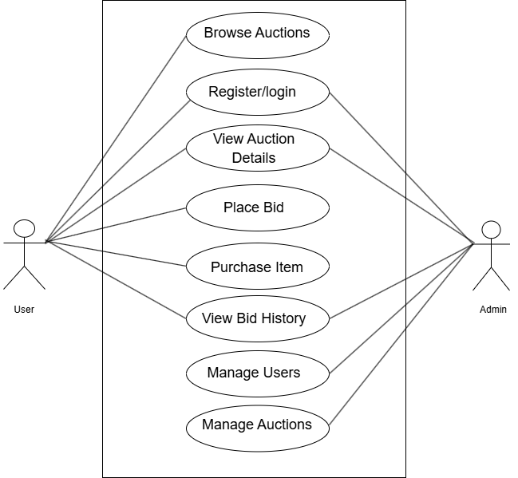

fig: Use case Diagram

**Use Cases and Actor Interactions**

1. **Browse Auction**
   * **Actor**: User
   * **Description**: Allows guests or registered users to browse the list of available auctions without logging in. This encourages public visibility and attracts more users.
2. **Register/Login**
   * **Actor**: User, Admin
   * **Description**: Enables users and admins to securely authenticate. Registration is required for users to participate in bidding and purchasing, while admins log in to access management features.
3. **View Auction Details**
   * **Actor**: User, Admin
   * **Description**: Provides detailed information about individual auction lots (e.g., artwork, artist, starting bid). Both users and admins access this to track bidding and auction activity.
4. **Place Bid**
   * **Actor**: User
   * **Description**: Authenticated users can place bids on auction items. This is central to the auction system, enabling competitive offers on listed items.
5. **Purchase Item**
   * **Actor**: User
   * **Description**: After winning a bid, users can proceed to finalize the purchase. This includes payment and order confirmation.
6. **View Bid History**
   * **Actor**: User, Admin
   * **Description**: Displays previous bids placed by a user. Admins can view this for monitoring and dispute resolution purposes.
7. **Manage Users**
   * **Actor**: Admin
   * **Description**: Admins can add, update, or remove user accounts, monitor user activity, and enforce platform rules.
8. **Manage Auctions**
   * **Actor**: Admin
   * **Description**: Admins can create, edit, or delete auction entries, upload artwork details, and schedule auction dates.

**Overall System View**

This use case diagram effectively outlines the scope of the system by separating user and admin responsibilities. It ensures that public functionality (like browsing and viewing auctions) is accessible, while administrative tasks are secure and controlled.

##### Class Diagram:

The class diagram presented models the structural foundation of the proposed online auction system. It outlines the main entities involved in the platform and their relationships, providing a blueprint for database design and system logic. The system comprises six core classes: Admin, User, Category, Auction, Bid, and Purchase.

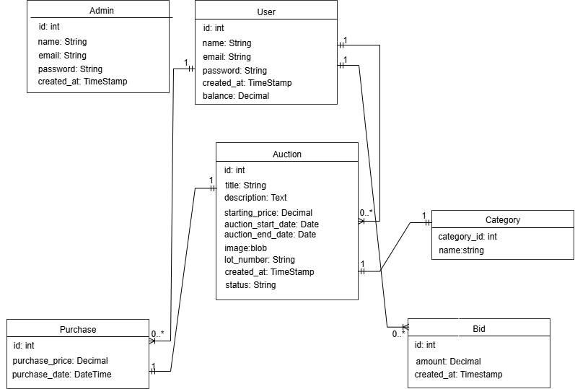

fig: Class Diagram

Class Descriptions:

* **Admin**:  
  This class stores details of administrative users who manage the auction platform. It includes attributes such as id, name, email, password, and created_at. Admins have elevated privileges and are responsible for managing users, auctions, and other backend tasks.
* **User**:  
  Represents clients or participants in the auction. Each user has an id, name, email, password, a registration timestamp (created_at), and a balance representing the user's funds on the platform. Users can create auctions, place bids, and purchase items.
* **Category**:  
  Defines different types or classifications for auction items (e.g., Paintings, Sculptures). Each category has a category_id and a name. Every auction item must be assigned to one category to improve filtering and organization.
* **Auction**:  
  Represents individual auction listings. Attributes include the title, description, starting_price, auction_start_date, auction_end_date, image (to store artwork images), lot_number, created_at, and status (e.g., open, closed, sold). Each auction is created by a user and belongs to one category.
* **Bid**:  
  Captures bidding activity on auctions. Each bid includes an id, the amount offered by the user, and a created_at timestamp. Bids are linked to both the User who places them and the Auction they’re placed on.
* **Purchase**:  
  Records final purchases of auctioned items. It includes a unique id, the purchase_price, and the purchase_date. A purchase is linked to both the user who buys the item and the auction from which the item was sold.

**Relationship Summary:**

* A **User** can:
  + Create multiple **Auctions**.
  + Place multiple **Bids**.
  + Make multiple **Purchases**.
* An **Auction** can:
  + Receive multiple **Bids**.
  + Be sold in one **Purchase**.
  + Belong to one **Category**.
* A **Category** can:
  + Categorize multiple **Auctions**.

This diagram provides a clear structure for implementing the system’s database and logic in alignment with both user and business requirements.

##### Wireframe:

The homepage wireframe is designed to provide users with a clean, intuitive, and welcoming entry point into the auction system. It focuses on usability, easy navigation, and quick access to key functionalities.

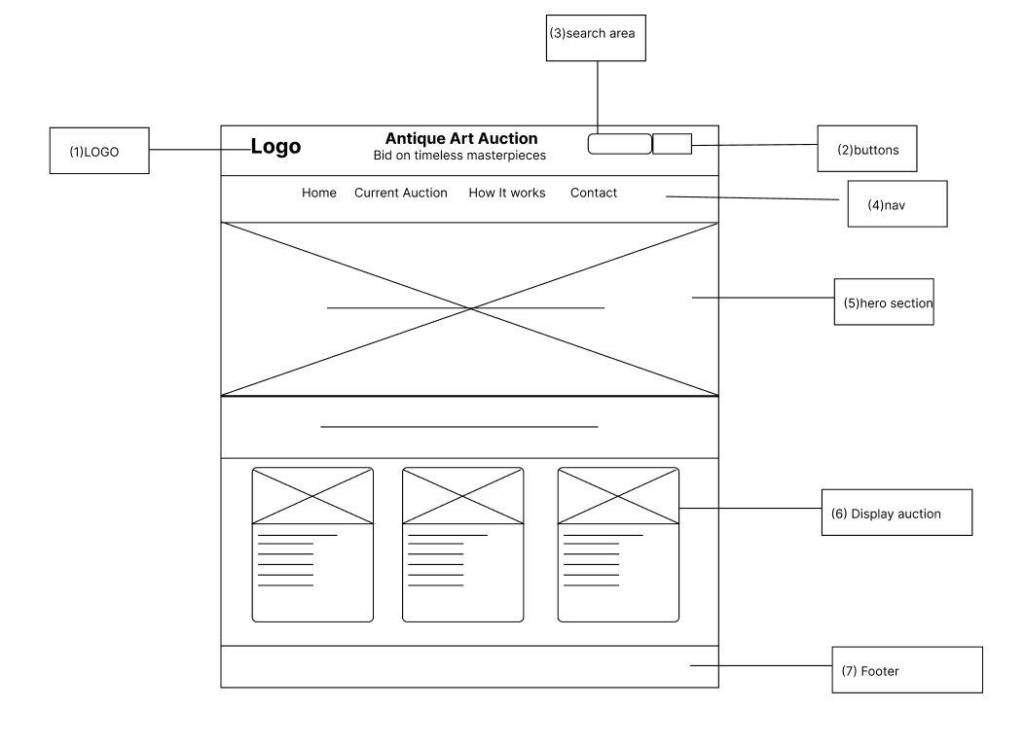

**Header Section**

* **Contains logo, search bar, and main navigation links: *Home*, *Contact*, *How It Works*, *Current Auctions*.**

**Hero Section**

* **Displays a large image with overlay text introducing the platform.**

**Login Prompt**

* **Positioned just below the hero image for user sign-in or registration.**

**Auction Listings**

* **Shows current auctions in a clean, card-style layout for easy browsing.**

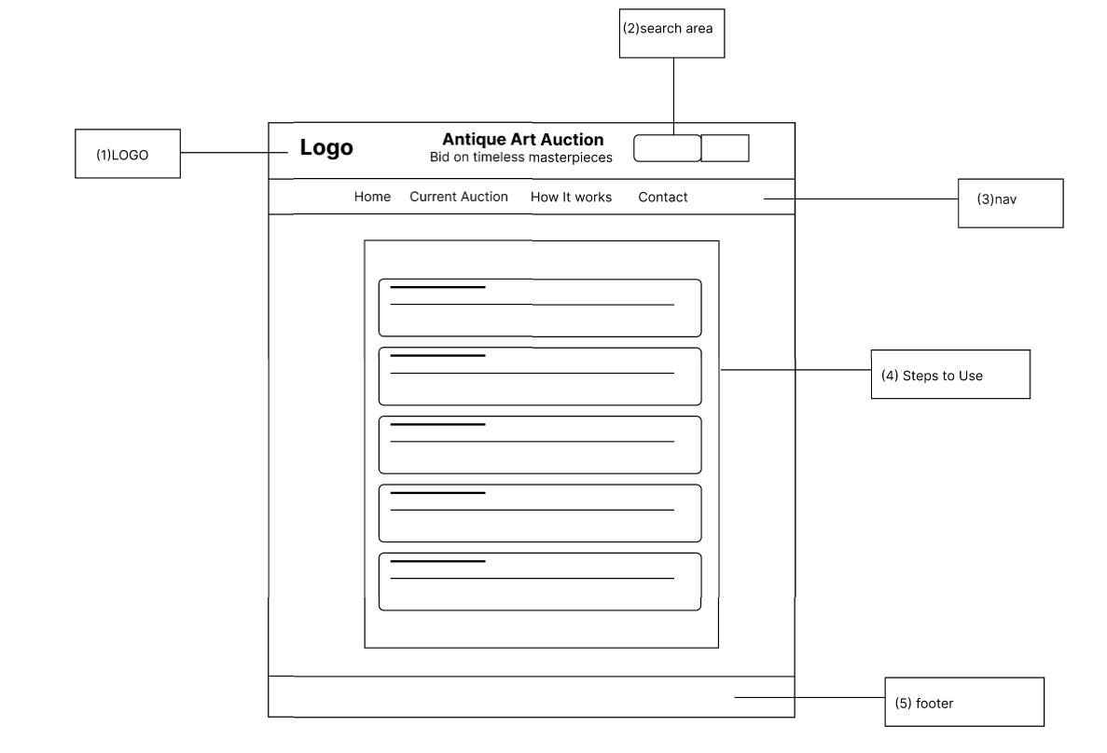

The "How It Works" page is designed to guide new users through the auction process with clear, structured information. It provides an overview of the steps involved in participating in auctions, from registration to bidding and purchasing.

**Key Features:**

* Consistent **header** with logo, navigation (Home, Contact, How It Works, Current Auctions), and search bar.
* Replaces hero section with a clean **content layout** focused on instructional material.
* **Informational cards** that explain:
  + How to register and log in.
  + How to browse and search for auctions.
  + How to place bids.
  + How to purchase items and complete a transaction.
  + Tips for successful bidding.

The "Current Auctions" page is designed to showcase live auction listings in a clean and organized format. It allows users to easily browse and view ongoing auctions, with key details and interactive elements to encourage participation.

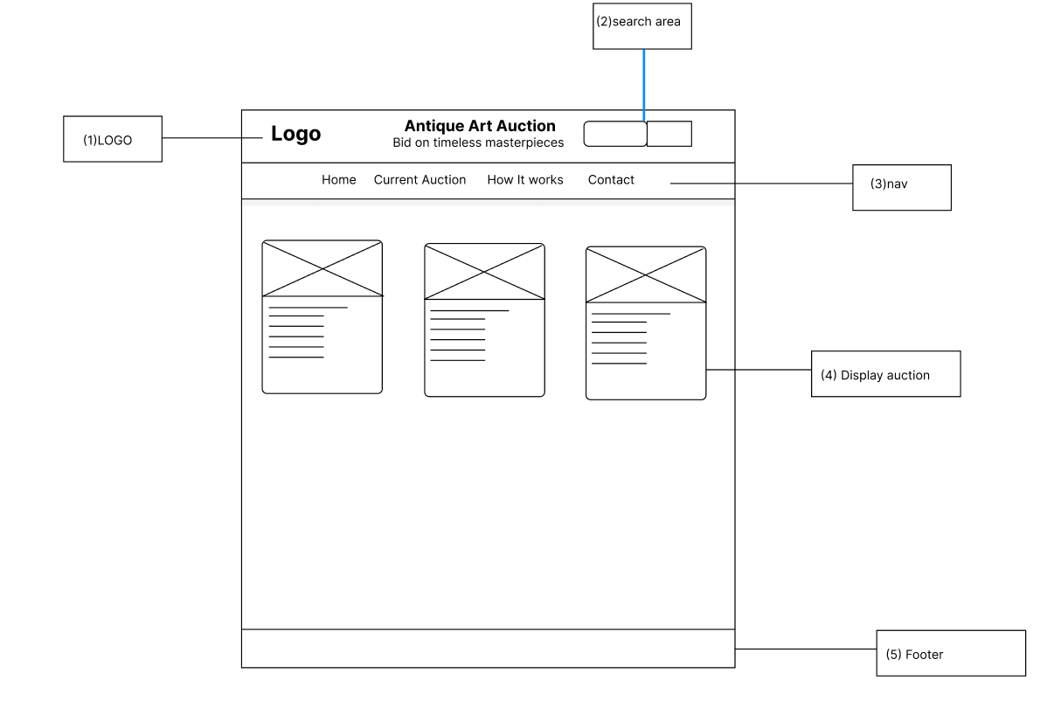

**Header Section**:  
Same as other pages, featuring the logo, search bar, and navigation links (Home, Contact, How It Works, Current Auctions).

**Main Content**:

**Auction Listings**: Displayed in a card-based format, with each auction card showing essential details such as:

* + Thumbnail image of the item
  + Description
  + Time remaining
  + Starting bid

##### Mockup for User Homepage:

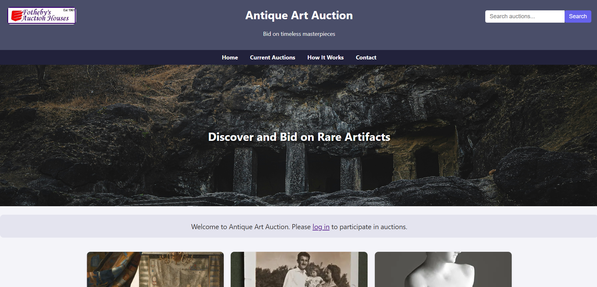

##### Mockup for Admin Homepage:

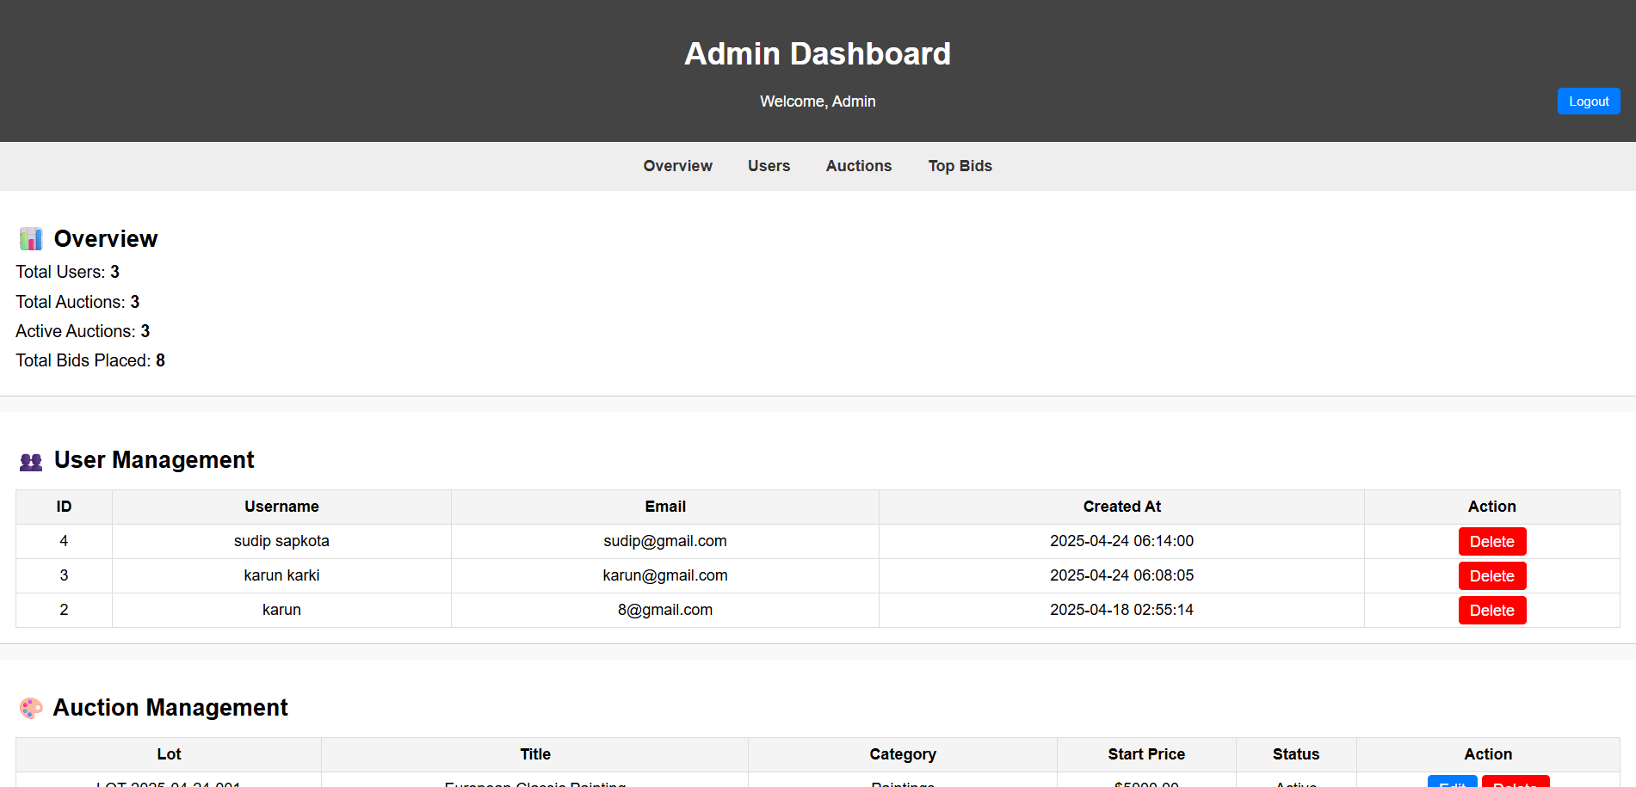

# System Build and Technical Notes (Software Development Block/Sprint 1)

The initial development of the Fotheby’s online auction platform is carried out using PHP as the primary server-side scripting language. PHP is chosen for its wide adoption in web development, ease of integration with HTML, and compatibility with various hosting environments. For data management, the system uses MariaDB, a robust and reliable relational database that supports efficient handling of auctions, bids, user accounts, and purchases.

The development environment is based in Visual Studio Code (VS Code), which offers a lightweight yet powerful interface for coding. It supports extensions, version control (Git), and debugging tools, all of which contribute to an efficient and organized build process during the early sprint stages.

# System Testing & Evaluation Strategy (Software Development Block/Sprint 1)

This testing approach focuses on evaluating system functionality without knowledge of internal code structures. The goal is to ensure that each component behaves correctly based on given inputs and expected outputs.

|  |  |  |  |  |  |
| --- | --- | --- | --- | --- | --- |
| **Test Case** | **Input** | **Expected Output** | **Actual Output** | **Pass/Fail** | **Description** |
| User Registration | Valid email, strong password, matching confirm | Account created successfully | Account created | Pass | Tests if new users can register with valid information. |
| User Registration | Invalid email, weak password | Error message prompting correct input | Error shown | Pass | Checks system validation on improper input during registration. |
| User Login | Correct email & password | Redirect to homepage | Redirected | Pass | Verifies that registered users can successfully log in. |
| User Login | Incorrect credentials | "Invalid login" message | Error shown | Pass | Confirms login failure when incorrect details are provided. |
| View Auction Listings | Page load request | Active auctions displayed | Listings displayed | Pass | Ensures auction items are correctly fetched and shown to users. |
| Place Valid Bid | Amount higher than current highest bid | Bid accepted and recorded | Bid accepted | Pass | Validates bid acceptance for eligible amounts. |
| Place Invalid Bid | Lower than current bid | Bid rejected with validation message | Bid rejected | Pass | Tests that the system rejects ineligible or lower bids appropriately. |

# Conclusion

The development of the online auction system has followed a structured approach, from conceptualization through system design to initial implementation. The system’s core functionalities, including user registration, bidding, and auction management, have been implemented with a strong focus on usability and efficiency. Unit testing, particularly black-box testing, has played a crucial role in validating the system’s components, ensuring that each feature functions correctly from a user perspective without requiring knowledge of the internal code structure.

Through the tests conducted, the system has demonstrated its ability to handle core operations such as user registration, login, viewing auction listings, and placing bids successfully. Any issues or failures identified during testing have been addressed, ensuring that the system is robust and user-friendly.

Moving forward, additional testing will focus on integration and system-level functionalities to ensure all components work seamlessly together. Continuous improvements and refinements will further enhance the user experience and ensure the platform meets the needs of its users effectively.

This structured approach to development and testing ensures that the auction system is stable, secure, and ready for deployment, providing a solid foundation for future enhancements.

# References

Anon., 2025. *Sotheby's.* [Online]   
Available at: https://help.sothebys.com/en/support/solutions/articles/44002518078-guide-for-buyers-global  
[Accessed 11 may 2025].

Anon., n.d. *ebay.* [Online]   
Available at: https://www.ebay.com/help/buying/bidding/bidding?id=4003  
[Accessed 2025].

Anon., n.d. *eBay.* [Online]   
Available at: https://www.ebay.com/help/selling/listings/selling-auctions?id=4110  
[Accessed 2025].

Sotheby's, n.d. *fine art,jewels.* [Online]   
Available at: https://www.sothebys.com/en/  
[Accessed 11 may 2025].